第一步：打开Anaconda Prompt
输入安装依赖命令：
pip install pylusat geopandas rasterio shapely
第二步： 打开代码所在文件夹的目录（代码仓库目录）
D: （先输入所在盘-替换自己的盘）
cd lcx\qudong\pylusat-0.5.0（替换自己的目录）
第三步：启动jupyter复现代码
输入命令：jupyter notebook
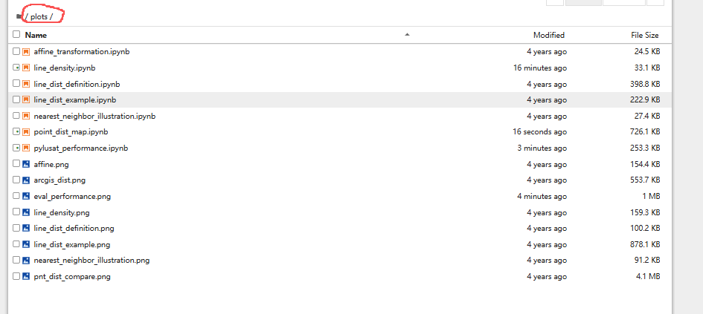
第四步：找到 plots
依次打开line_density.ipynb
import matplotlib.pyplot as plt
%matplotlib inline
from matplotlib import patches
import numpy as np
import pandas as pd
import geopandas as gpd
import matplotlib
from rasterio.plot import show
from matplotlib.patches import Polygon
from matplotlib.collections import PatchCollection
streets_gdf = gpd.read_file("./../pylusat/datasets/streets/streets.shp")
from pylusat.utils import rasterize_geometry
streets_arr = rasterize_geometry(streets_gdf, 20)
ax.set_aspect('equal')
left, right, bottom, top = 554676, 559500, 622563, 627232
ax.set_xlim(left, right)
ax.set_ylim(bottom, top)
levels = [0, 1, 2]
colors = ['white', 'steelblue']
cmap, norm = matplotlib.colors.from_levels_and_colors(levels, colors)
polygon_list = []
for i in range(3):
# point_list = []
for j in range(4):
# x = left + np.random.randint(0, (j+1)*10)*100
# y = bottom + np.random.randint(0, (j+1)*10)*100
arr = np.array(to_convex_contour(5, i+j+26))
arr[:,0] = arr[:,0]*1500 + i*1500 + left + 100*j
arr[:,1] = arr[:,1]*1500 + i*1500 + bottom + 100*j
polygon = Polygon(arr, edgecolor="red", facecolor="red",
linewidth=3, alpha=0.4)
ax.add_patch(polygon)
show(streets_arr[0], cmap=cmap, ax=ax, transform=streets_arr[1])
plt.tight_layout()
fig.savefig("./line_density.png", dpi=450)
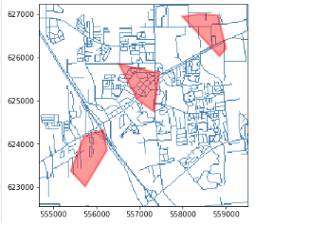
和 pylusat_performance.ipynb复现
import numpy as np
import pandas as pd
import plotly.graph_objects as go
pnt_dist_csv = "../pylusat/datasets/csv/pnt_dist.csv"
pnt_dist_df = pd.read_csv(pnt_dist_csv)
pnt_dist_df['number of points'] = pnt_dist_df['number of points'].apply(
lambda x: "{0:}k".format(x//1000)
)
fig = go.Figure()
fig.add_trace(go.Bar(
x=pnt_dist_df['number of points'],
y=pnt_dist_df['pylusat.dist.to_point()'],
name='pylusat.dist.to_point()',
# marker=dict(
# color=pnt_dist_df['pylusat dist.to_point()'],
# colorscale='Redor'
# ),
marker_color='rgba(204,204,204,0.5)',
# orientation='h'
))

fig.add_trace(go.Bar(
x=pnt_dist_df['number of points'],
y=pnt_dist_df['ArcGIS Near Function'],
name='ArcGIS Near function',
marker_color='rgba(49,130,189,0.7)',
# orientation='h'
))

fig.update_traces(texttemplate='%{y:.2f}', textposition='outside')
fig.update_xaxes(showgrid=False, title='total number of measurements')
fig.update_yaxes(showgrid=True, title='time cost (s)',
gridwidth=1, gridcolor='gainsboro')
fig.update_layout(
width=1000, height=470,
showlegend=True,
plot_bgcolor='rgba(0,0,0,0)',
legend=dict(
yanchor="bottom",
y=0.9,
xanchor="left",
x=0,
bgcolor='rgba(0,0,0,0)'
)
)

# fig.write_image("point_dist.png", scale=5, width=1000, height=470)
fig.show()
line_dist_csv = "../pylusat/datasets/csv/line_dist.csv"
line_dist_df = pd.read_csv(line_dist_csv)
line_dist_df['number of points'] = line_dist_df['number of points'].apply(
lambda x: "{0:}k".format(x//1000)
)
fig = go.Figure()
fig.add_trace(go.Bar(
x=line_dist_df['number of points'],
y=line_dist_df['pylusat.dist.to_line()'],
name='pylusat.dist.to_line()',
marker_color='rgba(204,204,204,0.5)',
))

fig.add_trace(go.Bar(
x=line_dist_df['number of points'],
y=line_dist_df['ArcGIS Near function'],
name='ArcGIS Near function',
marker_color='rgba(49,130,189,0.7)',
))

fig.update_traces(texttemplate='%{y:.2f}', textposition='outside')
fig.update_xaxes(showgrid=False, title='total number of measurements')
fig.update_yaxes(showgrid=True, title='time cost (s)',
gridwidth=1, gridcolor='gainsboro')
fig.update_layout(
width=1000, height=470,
showlegend=True,
plot_bgcolor='rgba(0,0,0,0)',
legend=dict(
yanchor="top",
y=0.97,
xanchor="left",
x=0,
bgcolor='rgba(0,0,0,0)'
)
)

# fig.write_image("line_dist.png", scale=5, width=1000, height=470)
fig.show()
line_den_csv = "../pylusat/datasets/csv/line_density.csv"
line_den_df = pd.read_csv(line_den_csv)
line_den_df['total number of measurements'] = line_den_df['total number of measurements'].apply(
lambda x: "{0:}k".format(x//1000)
)
fig = go.Figure()

fig.add_trace(go.Bar(
x=line_den_df['total number of measurements'],
y=line_den_df['pylusat.density.of_line()'],
name='pylusat.density.of_line()',
marker_color='rgba(204,204,204,0.5)',
))

fig.add_trace(go.Bar(
x=line_den_df['total number of measurements'],
y=line_den_df['ArcGIS model'],
name='ArcGIS model',
marker_color='rgba(49,130,189,0.7)',
))

fig.update_traces(texttemplate='%{y:.2f}', textposition='outside')
fig.update_xaxes(showgrid=False, title='total number of measurements')
fig.update_yaxes(showgrid=True, title='time cost (s)',
gridwidth=1, gridcolor='gainsboro')
fig.update_layout(
width=1000, height=470,
showlegend=True,
plot_bgcolor='rgba(0,0,0,0)',
legend=dict(
yanchor="top",
y=0.97,
xanchor="left",
x=0,
bgcolor='rgba(0,0,0,0)'
)
)
# fig.write_image("line_den_eval.png", scale=5, width=1000, height=470)
fig.show()
from plotly.subplots import make_subplots

fig = make_subplots(rows=3, cols=1,
shared_xaxes=True,
vertical_spacing=0.02)
fig.add_trace(
go.Bar(
x=pnt_dist_df['number of points'],
y=pnt_dist_df['pylusat.dist.to_point()'],
name='pylusat.dist.to_point()',
marker_color='rgba(204,204,204,0.5)',
),
row=1, col=1
)
fig.add_trace(
go.Bar(
x=pnt_dist_df['number of points'],
y=pnt_dist_df['ArcGIS Near Function'],
name='ArcGIS Near function',
marker_color='rgba(49,130,189,0.7)',
),
row=1, col=1
)
fig.add_trace(
go.Bar(
x=line_dist_df['number of points'],
y=line_dist_df['pylusat.dist.to_line()'],
name='pylusat.dist.to_line()',
marker_color='rgba(204,204,204,0.5)',
),
row=2, col=1
)
fig.add_trace(
go.Bar(
x=line_dist_df['number of points'],
y=line_dist_df['ArcGIS Near function'],
name='ArcGIS Near function',
marker_color='rgba(49,130,189,0.7)',
),
row=2, col=1
)
fig.add_trace(
go.Bar(
x=line_den_df['total number of measurements'],
y=line_den_df['pylusat.density.of_line()'],
name='pylusat.density.of_line()',
marker_color='rgba(204,204,204,0.5)',
),
row=3, col=1
)
fig.add_trace(
go.Bar(
x=line_den_df['total number of measurements'],
y=line_den_df['ArcGIS model'],
name='ArcGIS model',
marker_color='rgba(49,130,189,0.7)',
),
row=3, col=1
)
fig.update_traces(texttemplate='%{y:.2f}', textposition='outside')
fig.update_layout(
width=1000, height=1000,
showlegend=False,
plot_bgcolor='rgba(0,0,0,0)',
)
fig.update_yaxes(showgrid=True, title='wall time (s)',
gridwidth=1, gridcolor='gainsboro')
fig.update_xaxes(showgrid=False, title='total number of measurements', row=3, col=1)
fig.add_annotation(xref="paper", yref="y1", yanchor="top",
x=0.05, y=129, showarrow=True, arrowhead=7,
arrowsize=3, arrowcolor='rgba(204,204,204,0.5)', standoff=20)
fig.add_annotation(text="pylusat.distance.to_point()", xref="paper", yref="y1",
x=0.06, y=134, showarrow=False, yanchor="bottom")
fig.add_annotation(xref="paper", yref="y1", yanchor="top",
x=0.05, y=115, showarrow=True, arrowhead=7,
arrowsize=3, arrowcolor='rgba(49,130,189,0.7)', standoff=20)
fig.add_annotation(text="ArcGIS <i>Near</i>", xref="paper", yref="y1",
x=0.06, y=120, showarrow=False, yanchor="bottom")
fig.add_annotation(xref="paper", yref="y2", yanchor="top",
x=0.05, y=170, showarrow=True, arrowhead=7,
arrowsize=3, arrowcolor='rgba(204,204,204,0.5)', standoff=20)
fig.add_annotation(text="pylusat.distance.to_line()", xref="paper", yref="y2",
x=0.06, y=178, showarrow=False, yanchor="bottom")
fig.add_annotation(xref="paper", yref="y2", yanchor="top",
x=0.05, y=150, showarrow=True, arrowhead=7,
arrowsize=3, arrowcolor='rgba(49,130,189,0.7)', standoff=20)
fig.add_annotation(text="ArcGIS <i>Near</i>", xref="paper", yref="y2",
x=0.06, y=158, showarrow=False, yanchor="bottom")
fig.add_annotation(xref="paper", yref="y3", yanchor="top",
x=0.05, y=1250, showarrow=True, arrowhead=7,
arrowsize=3, arrowcolor='rgba(204,204,204,0.5)', standoff=20)
fig.add_annotation(text="pylusat.density.of_line()", xref="paper", yref="y3",
x=0.06, y=1300, showarrow=False, yanchor="bottom")
fig.add_annotation(xref="paper", yref="y3", yanchor="top",
x=0.05, y=1100, showarrow=True, arrowhead=7,
arrowsize=3, arrowcolor='rgba(49,130,189,0.7)', standoff=20)
fig.add_annotation(text="an ArcGIS model consisting of <i>Line Density</i> and <i>Zonal Statistics</i>", xref="paper", yref="y3",
x=0.06, y=1150, showarrow=False, yanchor="bottom")
fig.write_image("eval_performance.png", scale=5, width=1000, height=1000)
fig.show()